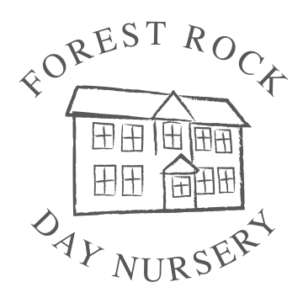
Application for a Nursery place

For further information or details, please contact
Kariena on 01509 891131

Child's full name: …..................................................……..............................
Date of birth: …......./........../..........

I would like my child to attend the Forest Rock Day Nursery for the following sessions (see Fee Information for exact session times). Please indicate with an X which of these sessions you prefer and we will try to meet your requirements.

 | Monday | Tuesday | Wednesday | Thursday | Friday
Full Week
Full Day
AM inc lunch
PM inc lunch
9am-3pm
TERM TIME only: 2, 3 and 4 year old Nursery Education Grant sessions
9-2
(Packed Lunch)
9-2
(Food Costs)
9-3
(Packed Lunch)
9-3
(Food Costs)

I would like my child to commence on: …......./........../..........

I have read and agree to the Nursery Regulations, Fee Agreement and Safeguarding Children Procedures of the Forest Rock Day Nursery. I have paid a non-refundable £50 registration fee by cash/cheque/bank transfer* (*please delete).
Forest Rock Day Nursery Bank Account Details; A/N: 62033190 S/C: 60-14-10
Parent/carer name: ……….………………………………………………………………………………………....

Address: …………………………………………………….................................................

……………………………………......... Post Code ……………………………….

Telephone numbers: …………………………………………………….................................................
Email Address: ……………………………………………………………………………………………………

Signed (Parent/carer):…......................................................... Date …............................

PLEASE NOTE: If a place is not taken up after one calendar month of the agreed start date, the Nursery reserves the right to re-offer your reserved place to another party.

